St. Margaret’s Bay Elementary School

Principal: Kelly Joy Vice Principal: Lynn Reichheld

Dear Families,

Thank you so much for being so supportive through our recent bout of increased illness at SMBE. We are so thankful for our custodial staff who came in for 8 hours this past weekend to deep clean our school. We at SMBE are so lucky to have such community support many families followed the public health directive and kept their children home for 48 hours after the virus and for that we are grateful. As we enter into next week, we want you to continue to keep your children home until they are healthy! We welcome all healthy students daily and hope that we are on the other side of the illnesses.

Please see some important information below:

Important Dates

November 17- Assessment and Evaluation Day- No Classes for students
November 22- Reports, Adaptations and IPP reports emailed home
November 23- No Students present PD in the morning
November 23- 1-3pm and 6-8pm afternoon and evening parent teacher, you will be hearing from your classroom teacher to set up appts.
December 12 Concert A
December 13 Concert B

Parent Teacher

We do not have a school wide system for booking interviews. Your child’s teacher will be reaching out to you via email to book an appointment time for November 23rd from 1-3pm and 6-8pm.

During the conference you can expect:
- How your child has progressed Sept - Nov
- What recommendations the teacher has for improvement
- Discussion of levels of support (adaptations, resource, speech, ELS, RR, LC)
- Please ask questions, share any information that can help student success, express areas of concern
Specialist contact information is as follows:
Ms. Edwards Music: JEdwards@hrce.ca
Ms. Dunn Music: MDunn@hrce.ca
Mr. Jollymore Phys Ed: AJollymore@hrce.ca
Mr. Terauds Phys Ed: MTerauds@hrce.ca
Mme. Aucoin (French): MAucoin@hrce.ca
Ms. Walsh(Resource): WalshM@hrce.ca
Ms. McGuire (Resource): mmcguire@hrce.ca
Ms. Lunney (ELS, RR): ELunney@hrce.ca
Ms. Walker (Learning Centre): Allyson.Walker@hrce.ca
Ms. MacRae (Learning Centre): Margaret.MacRae@hrce.ca
Ms. Anthony (Learning Centre): beverley.anthony@hrce.ca
Ms. Williams (Guidance Counsellor): jennifer.williams@hrce.ca

Term 1 Report Cards

Just a reminder that Term 1 Report Cards, IPPs and Adaptations will be distributed electronically on Wednesday, November 22, 2023. They will be emailed to the email address provided by parents in the Power School/Registration Documents with a link to your child’s report(s). To access the report(s) you will need to provide your student’s birthdate as a password. The birthdate must be entered as a YYYY-MM-DD. The dashes are mandatory. If this password does not work for you please contact Roberta at 902-826-3330

There is no mark or comment for Phys Ed, Music and French however you may book an apt with those specialists.

Concert Ticket Front Row Raffle

This year, our PTC will be having a Front Row Ticket Raffle which means they will be selling tickets so that three lucky families can win and upgrade their tickets from two regular entry into two front row seats…plus…one lucky family will also win one reserved parking spot in addition to their front row seats. So, there is NO waiting in line!

When: Tickets will go on sale during our parent teacher times on Thursday, Nov 23rd from 1-3 and 6-8
Where: Main Foyer outside the office
Cost: 1 ticket for $2 or 3 tickets for $5 (Cash only- Exact change would be appreciated)

If you are unable to get in during those times, please reach out to Ms. Roberta in the office on Thursday during regular school hours and we will send home a special request for front row ticket raffle form.

The Draw date will be December 11th at 1:30pm.

Green Christmas
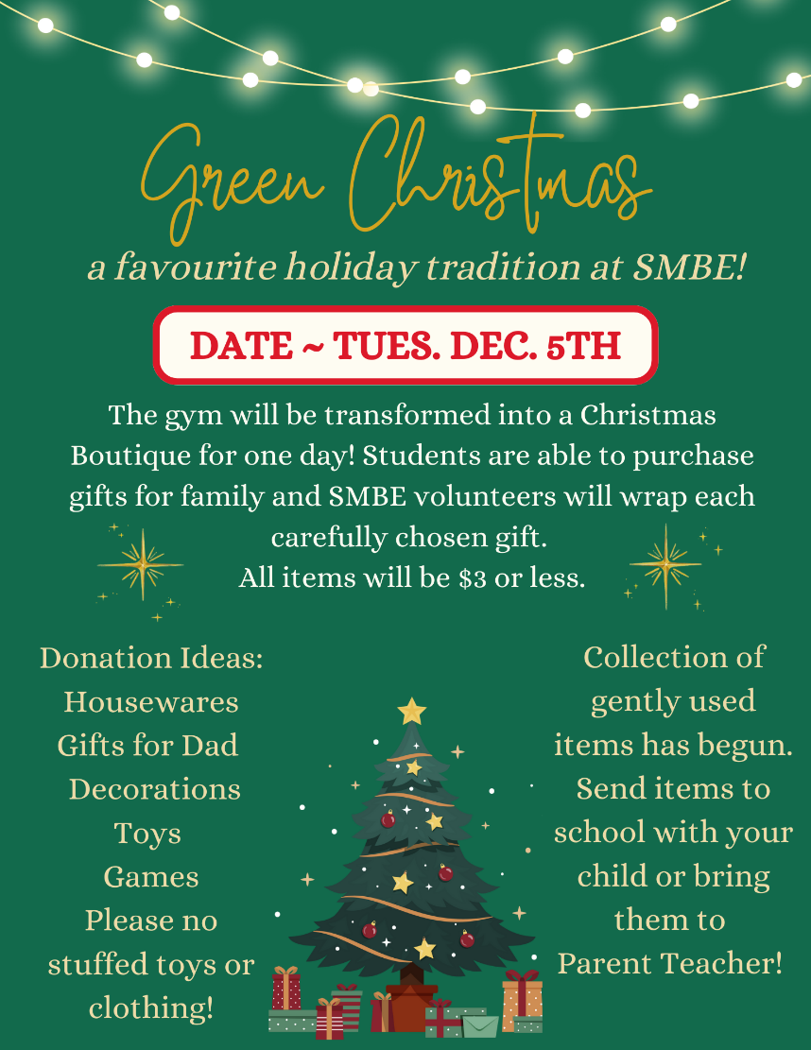

Green Christmas items can be dropped off at anytime including parent teacher day/night!

Green Christmas sign up…we have less than 50% of the volunteers needed. So if you can volunteer please sign up through the link https://volunteersignup.org/F3XCB or contact smbesptc@gmail.com

Holiday Concert

St. Margaret’s Bay will have two separate evening Holiday Concerts this year. Each family will get 2 tickets for the Holiday Concert. As you are aware we have limited seating capacity in our gymnasium and have had to divide the classes into two nights. Unfortunately, this will sometimes become complicated for families because your children are in different classes. Each family will get 2 tickets. If you have children on separate nights, you will get concert tickets for both nights. Meaning we will distribute about 460 tickets for each concert night. Unfortunately, we cannot offer childcare for this so it is requested that you make childcare arrangements as students cannot sit on their parents’ lap. The capacity is for all persons in the gymnasium which includes the music teacher, performers etc.

Concert A: Tuesday, December 12, 2023

1 Walsh
1/2 Ledroit
4 Fitch
5 MacDonald
3 Smith
3 Earley
4 Hughes
4 Fraser

Concert B: Wednesday, December 13, 2023

P Dawson
P Crummer
P/1 McDonald
1 Foley
2 Strong
2 Christie
2/3 Brown
5 Mosher
5 MacLellan

