Date: January 21, 2025
Format: Virtual
Present: Shauna Murray, Lynn Wyatt-Reichheld, Kelly Joy, Kirk Campbell, Katie Foley, Roberta Inglis, Harmonie Chafe-Webber, Ashley Hurshman
Regrets: Kelly Joy, Jessica Ledroit
- Welcome and call to order.
- Minutes: November minutes approved by Shauna and seconded by Ashley.
- Reports
  - Principals Report
Lynn provided the following update on behalf of Kelly as she had been off on medical leave:
- Kelly will be out for the next couple of weeks. I am now the Acting Principal and Jessica Ledroit came out of her grade 1 classroom to help the office, and we have a consistent substitute for those students and Jessica is working closely with her and still pulling students to do some targeted instruction when possible. Also shared that we have a couple of teachers out indefinitely- from the classroom, Pre-Primary, and Learning Center. All are currently covered.
- We had our Green Christmas back in December and it went very well. It raised $3007 and we didn’t have a whole lot of leftover items and most of what remained was able to go to East St. Margaret’s to help with their market.
- The Holiday concert took place and seemed to go well. There were many compliments and having the raffle draw was nice- two front row seats with parking thanks to our two designated reserved spaces. It brought in $347. (Side conversation- the PTC is thinking they will raise the cost of the tickets next year)
- Next Monday is Family Literacy Day and the school will be making it a literacy week with different tasks. What they will be is still to be determined. Some schools have family members come in on the Family Literacy Day, but we won’t be doing that as we don’t have the parking spaces, and we are noticing a fair number of absences due to illness, so we feel it’s best not to introduce even more bodies into our environment.
- February is African heritage Month. Teachers are brainstorming some things we would like to do and learn. We are looking to have someone from HRCE Arts come in and do a workshop with some classes beginning at grade five. Currently the proposal is to do some type of metal work art piece but it’s still at the early planning stage.
- Also, in February we are looking to have a Scholastic Book Fair the week of Feb 10-14th with students looking earlier in the week and purchasing later in the week and possibly staying open Wednesday from 3- 6pm so parents could stop in on their way home from work to look.
- Lastly, the Tattletales Campaign will run the same week as the Book Fair and to raise money for books for our school, the school will have a Sock Hop at lunch on Feb 14th and the students will donate $2 for it.

- Student Success Report
Lynn provided the following update on behalf of Kelly as she had been off on medical leave:
- Our Student Success Plan continues to focus on: Literacy (UFLi at P-2) and Fluency/Comprehension (3-5), Math (Numeracy P-2) and fact Fluency (3-5), Well-Being (Building relationships and Getting to Know our students
- Data (to be used to inform instruction and practices to disrupt inequities to provide rigorous learning opportunities for students of African and Indigenous ancestry and keeping the Inclusive Ed Policy at the forefront of our discussions and decision making.
- We are again at the point of identifying our Mid Term Reading Data for how our students are doing
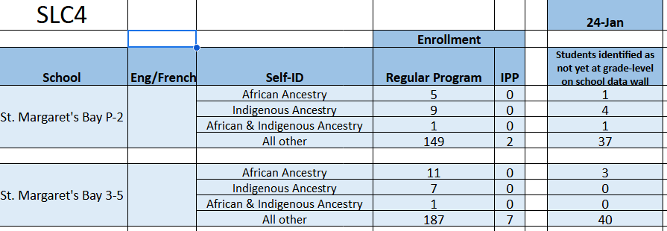
- Though there is not a lot to tell you with regards to specific data for writing and math at this time, teachers have been using their biweekly staff meetings to collaborating meet, learn and work together on looking at the writing and math SSP goals and ensuring that we are being consistent with what we are gathering as data and how are we assessing so that we are accurately identifying what students know and how we use the information to inform our instruction.
- With regards to well being, one of the things we have been talking about is the emotional well being of students and are they getting appropriate amounts of movement, especially for those that need it. An idea we have decided to go with is setting up sensory paths in the school. A “Movement Break Sensory Path” are found in the hallways and have posters or floor decals that provide a great hands-on fun think time or break for students to get their wiggles out and help re-regulate the body. Jessica Ledroit is spearheading the project as part of her masters and Lynn will support as she’s done similar things at her old school and knows how to use the school Cricut machine that we got last year as part of grant.

- Financial Report
Our opening balance was thought to be $5380 ($5000 plus $1 per primary to grade 5 students as of September 30th). However, the funds allocated at the end of November was $5413. The funds will need to be spent by June and we have our first request which will be discussed as part of the New Business.
- New Business
  - Teachers are requesting funds to purchase decodable books as they will support our SSP Reading goals and it will benefit those of our students who need the patterned text as opposed to levelled readers. They are looking for the Syllasense books, The Yak Pack Comics Set, and some decodable chapter books. Total monies requested to start building a library of these was $1500. Called for motion- All in agreement.
- Any Other Business
  - Lynn needs to still work with Ashley to get the SAC information regarding the role of a community member on the SAC so that we can try and recruit through the CEC (Community Enterprise Centre).
  - Lost and Found- brainstormed ideas to see how we can more items back to their rightful owners
    - see if we can have someone take pictures to share through PTC facebook site
    - see if they can be laid out at different times and allow parents to drop in until 6pm
    - remind families to label items (sharpie/ Mabels or Olivers Labels)
  - For our next meeting in February, it was agreed to have it on February 18th at 6pm.
- Meeting Adjourned at 7:14pm

