Date: **November 19, 2024**

Format: Virtual

**Present:** Shauna Murray, Lynn Wyatt-Reichheld, Kelly Joy, Kirk Campbell, Roberta Inglis, Falen Boutilier, Alicia Boutilier, Ashley Hurshman

**Regrets**: Harmonie Chafe-Webber, Katie Foley

* **Welcome** and **call to order**.
* **Minutes**: June minutes approved by Kirk and seconded by Roberta.
* **Reports**
  + **Principals Report**

Kelly shared the following items:

* Class Configurations (2 Pre-Primary and 16 classrooms with a combined at each grade level). All started at cap or hard cap (range from 20-27 depending on grade). No changes made after school started except for adding new students due to the high numbers).
* SAC meeting for Principals and SAC Chairs was held at the end of September to look at the provincial school code of conduct. Shawna was unable to attend so Harmonie graciously went with her. The policy is still under revision without a set date of implementation as of now. Lots of feedback is still being collected from shareholders and we look forward to seeing the new draft for continuity across the province.
* Universal lunch program (provided by Compass) is now up and running as of October 28th. Overall, it is going well as we have a red dot and green dot system to track who gets what. For the most part the students have been positive about the options provided. We provide ongoing feedback. We order extra to help support those that need it. (Kurt mentioned that on the indoor day the lunches were dropped off early for the last group, so we’ll monitor that for the next rain day and that he is unable to go back to see what was ordered and Ashley mentioned an email).
* We had a whole school assembly early in October called **Dream Catcher and the Seven Grandfathers presentation.** It was not what we were hoping it would be. We researched it and it seemed like it would check off all the boxes) but it seemed quite chaotic and that it could have been much more.
* Guest Speakers in the Schools- used as a learning resource (short term planning)- Kelly went over what the new guidelines and requirements are for us here at SMBE and HRCE and ensuring it connects to the curriculum.
* Kelly went to a principal’s sessions with Katie Novak, a UDL (Universal Design for Learning) expert.
* Kelly and Lynn went to a session with Dr. ABC, a speaker who stressed the importance of ensuring that students feel a sense of belonging.
* We had a lovely Remembrance Day Assembly put on by Lynn that was well received by the students and staff.
* Math Coach (Nicole Rogers) and Arts Specialist (Danny MacDonald) are currently working with teachers.
* Two holiday concerts coming up in December. Green Christmas coming up, Spirit Week the last week. Parent Teacher and report cards early December. Lost and Found is overflowing.
* **Student Success Report**

Kelly shared the following:

* Our Student Success Plan is currently focused on: Literacy (UFLi at P-2) and Fluency/Comprehension (3-5), Math (Numeracy P-2) and fact Fluency (3-5), Well-Being (Building relationships and Getting to Know our students
* Data (to be used to inform instruction and practices to disrupt inequities to provide rigorous learning opportunities for students of African and Indigenous ancestry and keeping the Inclusive Ed Policy at the forefront of our discussions and decision making.
* Mid Term Reading Data for how our students are doing was taken for all students with a focus on our P-2 students.

* LM3 Report for last year
  + 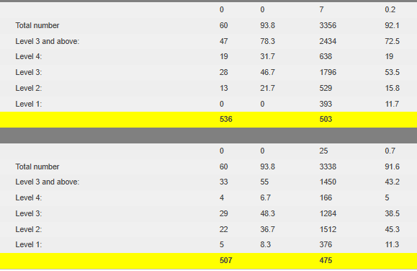Reading Results in comparison to HRCE
* WritingA screenshot of a data table

  Description automatically generated
  + Mathematics

* Additional classroom reading data will be collected by end of term to go into the Classroom Based Assessment System so we have a starting point for the year so that we can begin looking for trends and track student progress.
* End of Cycle One is in early December so that’s when we will report on how things are going and where we will be going next for cycle two.
* **Financial Report**

Our opening balance will be $5380 ($5000 plus $1 per primary to grade 5 students as of September 30th). The funds will be allocated towards the end of the month. The funds must be spent by the end of June. Teachers will be consulted on where the funds can best be used to support.

* **New Business**
  + Shawna suggested that when we are looking at well-being/wellness piece that teachers could have circles/team meetings that look at how things are going, feeling safe etc., check-ins.
  + SAC Members Recruited Harmonie Chafe-Webber and Ashley Hurshman. Fallen will remain with us until she moves in the new year. Alicia must step down as she is no longer covering this community. We still need a couple of community members. Ashley has provided an idea of how we might be able to recruit by going through the CEC (Community Enterprise Centre).
* **Any Other Business**
  + The SAC Grant that we applied for with regards to small (loose) parts play from last year was denied. We will try again and try to pull it together in a timelier manner and not have it feel so rushed.
  + Meeting dates: 6 Meetings so November, January, February, April, May, June
  + Thank you to the local Tantallon Superstore for the reusable treat bags and to Kris Gerrior Realty for school supply donations.
* **Meeting Adjourned** at 7:26 pm.